**ACQUISITION PROPOSAL OF LIONSGATE BY NETFLIX**

**Is Lionsgate Entertainment a profitable acquisition for Netflix?**

Mousa Sheikh & Raghav Arora

California Polytechnic State University, San Luis Obispo

**M&A Market Analysis**

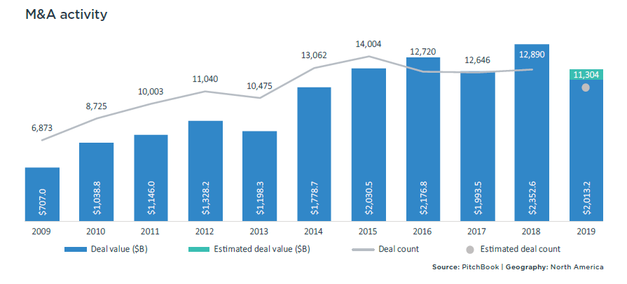

Despite a decline of 12.3% in M&A deal counts from 2018, 2019 saw yet another period of heavy investment from corporations and private equity funds into the mergers and acquisitions market. Of the two largest deals that took place in 2019, the pharmaceutical company Bristol-Myers Squibb’s (BMY) acquisition of Celgene (a pharmaceutical company focused on cancer treatment) was at the helm of these valued at $74 billion. Second in line was The Walt Disney Company’s acquisition of 21st Century Fox for $71.3 billion, which could be seen as an action that will further solidify the entertainment conglomerate as a major player amongst popular streaming platforms (given that they previously acquired Hulu in addition to possessing ESPN+) (Pitchbook).

The energy sector saw an overall fall in both M&A value and deal count, though the $57 billion deal between Occidental Petroleum (OXY) for Anadarko Petroleum still reigned as the third biggest acquisition of the year. The Information Technology sector accounted for nearly 20% of the value of M&A deals with Salesforce’s (CRM) acquisition of Tableau for $15.7 billion being the largest of the information technology acquisitions. An interesting development, however, is the rather stark decline in Chinese acquisition of American companies. Compared to 2018, last year saw a drop in deal count of 60.4%. Analysts believe that this is a result of the “shift in sentiment regarding the West’s view of the national security risks from foreign investment,” particularly regarding the technology segment where critical data and information is stored (Pitchbook 7). Of course, the U.S. is not the only country single handedly bringing up their suspicions, as the European Parliament recently developed measures to keep an eye on foreign investment. 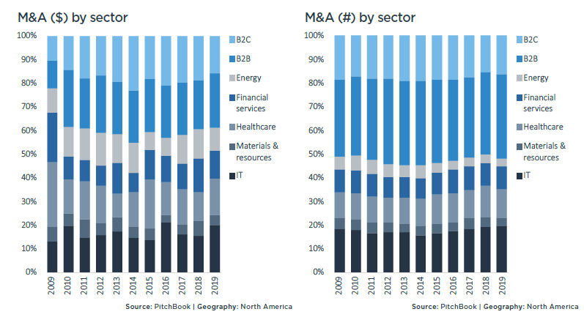

In the entertainment industry specifically, 2020 poses a plethora of potential deals to occur in the sector. As mentioned before, Disney already spent a copious amount of capital acquiring 21st Century Fox. In addition to this, the industry has seen other landmark deals such as AT&T capturing Time-Warner, and Viacom merging with CBS (Katz 1). According to an article by The Observer, however, few companies left in the acquisition field include “AMC, Discover, Lionsgate, Sony, Imagine Entertainment, and MGM Entertainment” (Katz 2). The prospects of mergers and acquisitions in the industry depend on the technological advances that have yet to surface in production. It’s clear that entertainment is no different from the tech scene in that it’s constantly changing. The Coronavirus pandemic is definitely putting a dent in many corporations’ bottom lines, as was seen with Disney’s quarterly earnings report where it was reported the entertainment mogul suffered a 58% drop in operating income (Feiner, Whitten 1). This will likely slow Disney’s involvement in mergers in acquisitions until the company can get back on its feet.

**Target and Acquirer Background**

1. **Acquirer: Netflix, Inc. (NFLX)**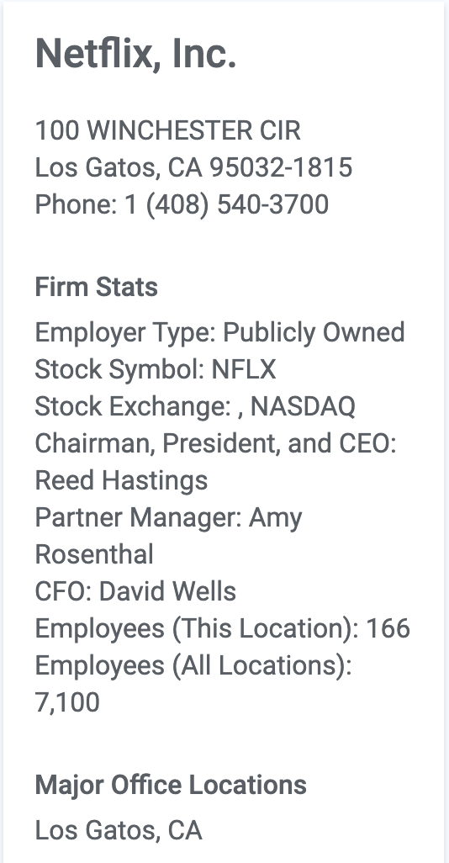

**About**: Netflix leads in the streaming industry by distributing movies and television shows in a wide set of genres and languages to roughly 139 million monthly paid subscribers in around 190 countries, cementing itself not only in the entertainment sector, but also a primary competitor to cable networks (Vault). Netflix went public in the year 2002, and has since displayed tremendous company growth with no signs of slowing down anytime soon.

**Operations:** Netflix organizes its structure in three operating segments. These are divided into domestic streaming, international streaming and domestic DVD. About 48% of Netflix’s revenue is driven from domestic streaming, 49% from international streaming, and 3% from DVD rentals. In regards to Netflix’s streaming services, it offers a suite subscription plans that vary by price, quality of streaming, amount of viewers and an optional DVD plan (NFLX, 2020). The ability to offer a subscription service at a low price (the highest being $15.99 per month), while delivering strong, consistent quality is one of the main reasons the media company has been able to sustain a competitive advantage (Netflix, 2020).

**Geography, Demographics, and Market Segments:** Netflix is a U.S. based company, and is headquartered in Los Gatos, California. Because of their resolute ability to stream high quality and fidelity to virtually anyone who has an internet connection, they are capable of pursuing an aggressive, global market development strategy. As mentioned prior, Netflix’s services are offered in over 190 different countries, showing that the company has the resources, and abilities of adapting to foreign markets (Netflix, 2020).

**Sales and Marketing:** Stepping onto the global stage is no walk in the park for any company, however, this is why Netflix takes a separate, but effective approach in promotion and advertising. Though the company has seen increases in it’s marketing budget escalate from $1 billion to $1.8 billion during 2017 and 2018, SG&A have historically amounted to only about 20% of the overall revenue (NFLX). The aim is not to spend the most money, or be seen on the biggest billboards, but instead to utilize the easily-accessible resources, such as social media platforms and email-chains, to promote user engagement. The personalized presence, in addition, creates relatability amongst consumers, and this is a primary driver for user engagement (Siddiqi).

Further, Netflix prioritizes its experience around ease of use. The platform is accessible from almost any smartphone, smart T.V., or tablet, maintaining a simple user-interface that is easily translated across devices and languages (Bhasin). The core of keeping customers on Netflix, however, has always resided in the content (Netflix, 2020). The company strikes tremendous deals with licensing companies to hold a premium catalog of entertainment, while simultaneously producing their own - these are labeled ‘Netflix Originals’ (Bhasin).

It operates by offering one month free trials for first time subscribers. From that, there are price point changes offering the Standard plan (two HD streams) from $10.99 to $12.99 per month; the Premium plan (up to four Ultra HD streams) from $13.99 to $15.99 per month; and the Basic plan (with a single non-HD stream) from $7.99 to $8.99 per month, which is a testament to Netflix’s increasing revenue.

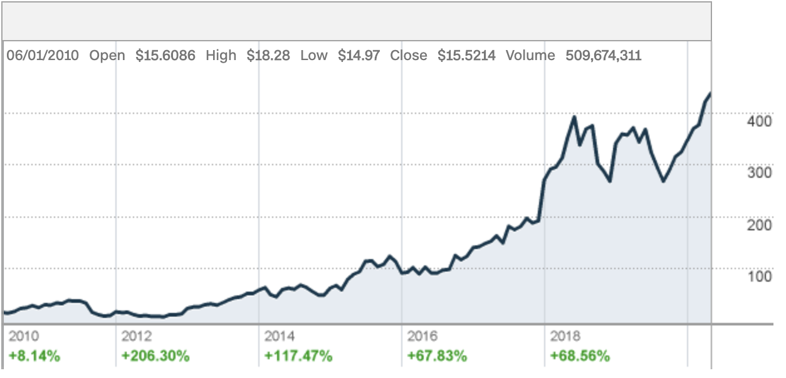

**Financial Performance:** The increasing demand of internet use across the globe, coalesced with the widespread growth of broadband technology, consumers have seen a vast increase in their usage of digital media content; this has allowed Netflix to significantly grow its streaming platform. In the past 5 years alone, Netflix’s revenue has increased over 186% driven by growth in the number of paid subscriptions. Netflix added 29 million paid subscribers in 2018. Moreover, Domestic streaming revenue increased 24% year-over-year and international streaming grew 53% (Vault 2). Revenue from the legacy DVD business, however, has continued to drop as the ease of streaming continues to take over the market. Growth in revenue, operating margin, and net income has enabled the company to absorb higher expenses as it continued to invest heavily on programming, R&D, and headcount. Netflix spent $12 billion on content in 2018, and saw pure cash intakes worth $2.6 billion at the end of that year, which was over $500 million from the previous year (Netflix, 2020). From 10-K statements retrieved from the SEC, it’s clear that Netflix is fairly leveraged with a D/E ratio of about 1.94 (as of the end of 2019) continually trending downwards. This a healthy position to be in for the entertainment mogul, as it continues to hold the majority market share in the streaming sector.

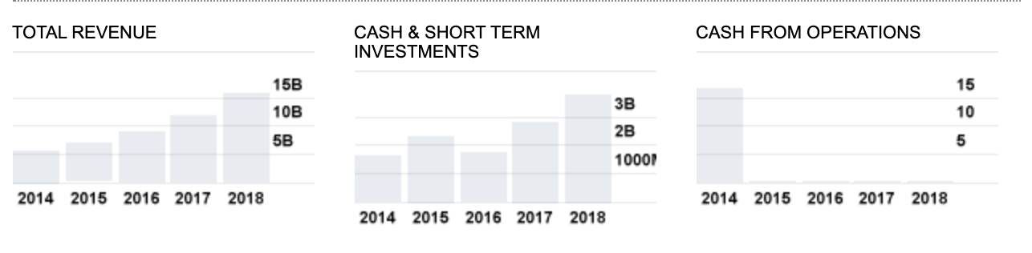

**Netflix Strategy:** Netflix main strategy is to increase the number of subscriptions per year on a global scale, while also improving customer experience. They have done so by investing heavily in content creation. As stated prior, Netflix spends a vast amount of capital acquiring top-tier content. This strategy is followed to beat other competitors such Hulu, Amazon, HBO. The firm continues to explore strategic agreements with TV networks and pay channels while also producing content in-house. Additionally, Netflix also challenges conventional movie industry norms to face competitors. For example, Netflix refuses to grant movie theatres exclusive release.

**SWOT Analysis (Rivera, 2019):**

|  |  |
| --- | --- |
| Strengths | 1. High brand equity 2. Large platform of content producers and consumers 3. High capacity for content creation. |
| Weaknesses | 1. Imitable business model 2. Dependence on content producers 3. Dependence on Internet service providers |
| Opportunities | 1. Growth through expansion of product mix 2. Penetration in new markets 3. Business diversification into other industries or markets |
| Threats | 1. Competition and imitation 2. Entertainment media/content piracy 3. Cybercrime |

1. **Target: Lions Gate Entertainment Corp (LGFB)**

**About:** Lionsgate is a Canadian based production company that engages in motion picture production and distribution, television programming and syndication, home entertainment, and international distribution. Moreover, Lionsgate also holds a share of the interactive gaming and virtual reality market. The company has long since been present in the consumer services sector with emphasis in the movies/entertainment industry, and has been a primary subject of acquisition from the view of many telecom companies for the past few years (CNN Money, 2020). 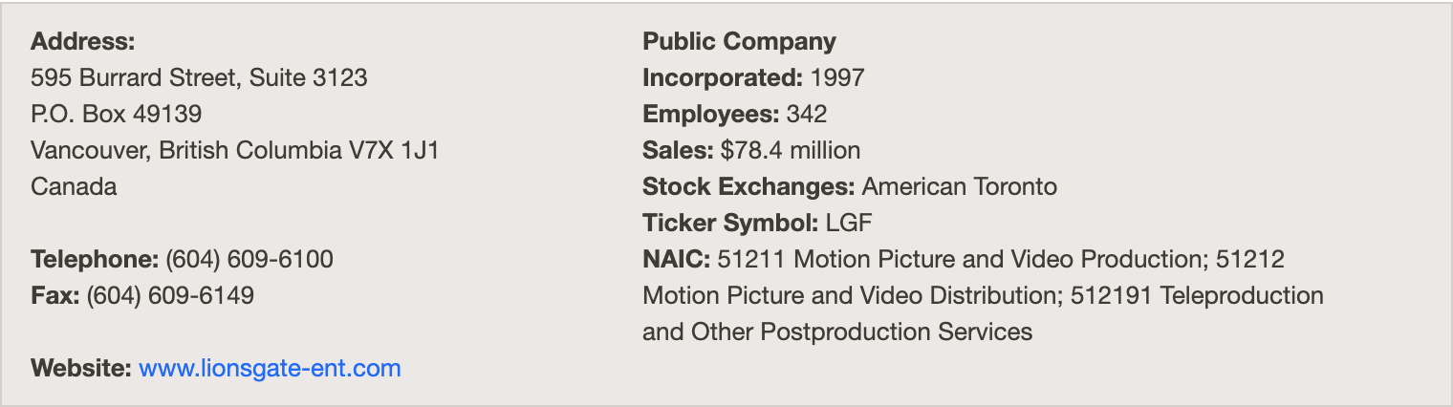

**Operations:** Like Netflix, Lionsgate also operates under three business segments namely motion pictures, media networks, and television production. The motion picture segment includes the development and production of feature films, such as The Hunger Games, Knives Out, and American Psycho to name a few. Its content initiatives are backed by a 17,000-title film and television library, delivered globally through a developed licensing infrastructure. The motion picture group consists of eight major film labels and includes over 40 feature film releases per year. Lionsgate’s motion picture group grossed nearly $10 billion at the global box office, earning 122 academy award nominations and 30 oscar wins solely in the past 5 years (Lionsgate, 2020).Lionsgate television production segment consists of development, production and distribution of T.V series and T.V movies. It is one of the biggest television businesses with over 90 series on 40 different networks. Finally, Lionsgate media network segment is partnered with Starz network which works with licensing of premium subscription video programming in the United States. Since the introduction of Starz in 2018, Lionsgate has added over 7 million subscribers with a highly successful over-the-top offering and a global expansion into several countries, through partnerships with leading streaming platform services (Lionsgate, 2020).

**Geography:** The company was founded by Frank Guistra in 1987 and is headquartered in Santa Monica, CA. It has over 1.42 thousand employees worldwide (CNN Money, 2020).

**Sales and Marketing:** In 2019, Lionsgate held a market share of about 7.07% in the movie/entertainment industry by releasing 21 movies. They sold over 87 million tickets and grossed over $750 million in sales (Investis). 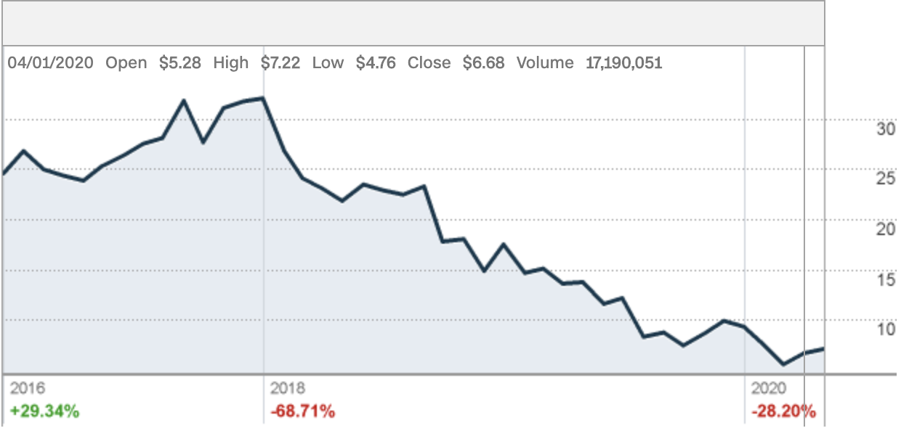

**Financial Performance:** At the end of June of 2019, Lionsgate reported revenue totaling $963.6 million, however a net loss equal to $54 million. Their net loss per share was attributed to $0.25. The company also incurred an operating loss of $3.2 million and an adjusted OIBDA of $67.3 million. Cash Flow from operations equalled $37.3 million. In terms of their segments, motion pictures revenues increased to $397.8 million over the quarter, driven by strong theatrical performance from John Wick 3. However, profits, in fact, declined from 2017 ($7.6 million), which reflected an increase in P&A spending (CNN Money, 2020). With regards to television production, revenues matched last years with a 60.3% increase in profits to $25 million. Lastly, media segment revenues increased by 4.9% driven by high subscriber growth to total $372.4 million (Investis 2).

**Strategy:** Lionsgate follows a three way strategy. First is the recognition of changing times and adapting to the ever growing digital media technology. The company is currently investing heavily in an international expansion with emphasis in building technological platforms. Second, is to pair with other streaming services in forming profitable synergies. Lionsgate acquisitions of Starz increased revenues by 1.8% and increased the subscriber base by 2.6 million in 2019 alone. Lastly, Lionsgate strategizes in heavy investment into content. In order to fuel the cable TV and streaming platforms with fresh content, the Starz division of Lionsgate started up more than 80 different projects over the last year and a half (Lionsgate, 2020).. 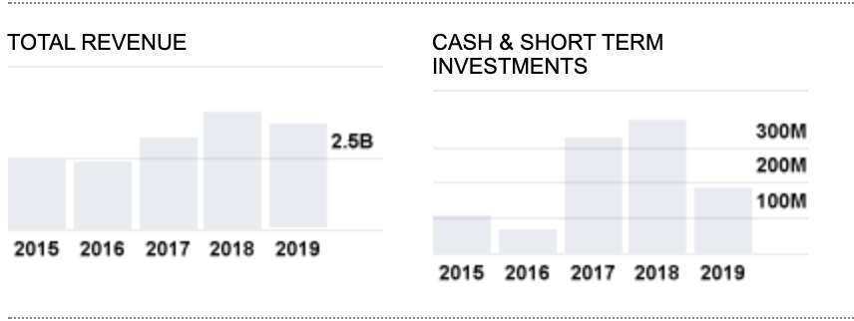

**SWOT Analysis (Fenn Fort, 2019):**

|  |  |
| --- | --- |
| Strengths | 1. It owns the following Divisions – Lionsgate Films, Lionsgate Premiere, Lionsgate Television, Lionsgate Home Entertainment, Lionsgate Music & Publishing. 2. It is the seventh most profitable movie studio 3. It is the leader in television distribution in North America. 4. Lionsgate Films focuses on independent films, it has distributed The Twilight saga, The Hunger Games etc. 5. Lionsgate has high diversification of products and services in the entertainment industry. 6. Superb Performance in New Markets 7. Reliable suppliers 8. Strong Brand Portfolio. 9. Highly skilled workforce through successful training and learning programs. 10. Strong distribution network 11. High level of customer satisfaction 12. Good Returns on Capital Expenditure |
| Weaknesses | 1. Declining revenues in the entertainment industry 2. The profitability ratio and Net Contribution % of Lions Gate Entertainment Corp. are below the industry average. 3. The marketing of the products left a lot to be desired. 4. Organization structure is only compatible with present business models thus limiting expansion in adjacent product segments. 5. Need more investment in new technologies. 6. High attrition rate in workforce 7. Not very good at product demand forecasting leading to higher rate of missed opportunities compared to its competitors. 8. Not highly successful at integrating firms with different work cultures. |
| Opportunities | 1. Expansion to markets outside of USA 2. Starting the production of animated movies/series whose demand is growing. 3. Providing more entertainment options online like expanding its video on demand services 4. New trends in the consumer behavior can open up new market for Lionsgate 5. New customers from online channel 6. The new taxation policy can significantly impact the way of doing business and can open new opportunities for established players such as Lions Gate Entertainment Corp. to increase its profitability. 7. The new technology provides an opportunity to Lions Gate Entertainment Corp. to practice differentiated pricing strategy in the new market. It will enable the firm |
| Threats | 1. High international competition 2. The entertainment market for movies and television is a mature market 3. Threat from the online sources of entertainment. 4. Changing consumer buying behavior from online channels could be a threat to the existing physical infrastructure driven supply chain model. 5. Rising cost of wages and raw material. |

**Motivations: Synergies of Merger**

**Reasons for Merger:**

The acquisition of Lionsgate by Netflix should be classified as a horizontal acquisition since both companies are competing in relatively similar industries. Rather than being in separate points in the value chain, both of these corporations engage in similar activities to produce products and services as well. These include production expenses, partnerships, licensing and distribution strategies, and advertising expenses with little emphasis on capital expenditure (at least from Lionsgate’s perspective). However, part of this acquisition will directly affect Netflix’s value chain processes, thus it can also be considered a vertical acquisition. Certain assets such as production facilities and distribution deals will add to Netflix’s value chain. That being said, the primary synergy for this acquisition will be a cost reduction driver that Netflix can provide in taking control of Lionsgate’s assets, which include the licensing and distribution of any products the company has conceived. Previously mentioned, Netflix’s competitive advantage lies in the platform’s ease of use, superior catalog of content, and more importantly, it’s ability to mass-market its services while keeping expenses low. Lionsgate, a veteran movie production company, spends a great deal of resources on marketing its primary assets - movies - in cinemas, deals with competing streaming platforms, and merchandise to follow. Putting Lionsgate’s crucial assets in the hands of Netflix will create value that current shareholders will surely benefit from.

In regards to hard assets, Lionsgate has little to none that will serve as perpetual cash flows; less than 2% of Lionsgate’s assets can be auctioned off the merger. Since these assets (headquarters, satellite offices, miscellaneous equipment) will surely be sold, but will not make serious contributions to the overall return over the course of the takeover, asset reduction synergies will be of little to no value; a consideration, however, will be mentioned in the synergies valuation section ahead.

**Market Reaction:**

In regards to the market reaction, we expect Netflix's share price to decrease, and Lionsgate’s share price to increase (Andrew, 2020). Lionsgate’s stock price rises because Netflix pays a premium for the acquisition in order to incentivise target shareholders to approve the takeover. Furthermore, Netflix’s share price drops proportionally to the amount paid on acquiring Lionsgate. However, due to the current volatile conditions in the market, the market may react differently to this announcement.

**Target Valuation**

**Enterprise Value:**

Average and current share prices were obtained from Yahoo! Finance for Lionsgate, and then multiplied by average shares outstanding retrieved from financial statements sourced from Mergent Online, a database offered through Kennedy Library. The resulting value gives us the market value of equity, which is then used to find each company’s enterprise value. The spreadsheet shown below contains estimates of both the target and acquirers market value of equity, and their respective enterprise values. As of 2019, the target, Lionsgate, was valued at nearly $4.5 billion, and the acquirer, and Netflix at roughly $203 billion.

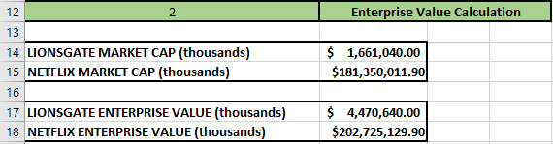

**Pro-Forma Analysis:**

A few assumptions must be made before proceeding: The first is taxation. Over the past five years Lionsgate has paid roughly 41% of its net income in taxes. This was calculated by dividing the taxes paid by total taxable income. It must be noted that historically, however, Lionsgate’s yearly tax rate has hovered around 15-20%, and only recently has jumped up in percentage, likely because they have been receiving an influx of cash from return on current pictures produced. This was especially true in the years of 2016-2017, where Lionsgate’s cash and cash equivalent holdings surged 457%, and as a result paid 60% and 91% of their income in taxes. Because of these anomalies, the tax rate was adjusted downwards to 35%, close to the average corporate tax rate.

Lionsgate has historically paid 21% of its net income to shareholders in the form of dividends. This assumption will continue to hold true with the pro-forma calculations in mind, but the dividends will be put into net new financing required for Netflix to maintain use of Lionsgate’s assets; this will be explained below in detail. In addition, a risk free rate of 2.99% the average of debt of 4.99% was chosen based on industry averages. Long and short term growth rates of 2.5% and 13% were chosen respectively. The short term growth rate was based on a horizontal analysis conducted on Lionsgate’s income statement. On average, Lionsgate’s total revenue grew at an average rate of about 13% in the past five years; this is not far from the entertainment industry average of about 10%.

The pro-forma analysis was conducted using an adjusted percentage of sales method, which essentially states that many line items on the income statement in the balance sheet will grow as they have historically moved as a percentage of the total revenue. Revenue for Lionsgate was grown at the average short term growth rate (2.5%) , and many items were projected with their respective percentage of revenue values from 2019. Certain line items are treated differently, however, when taking into account the cost-reduction synergies that will arise from the acquisition. For example, on the income statement, items such as direct costs, selling, general and administrative cost were adjusted downwards for reasonable expectations. S.G.A. expenses that previously would cost 35% of Lionsgate’s revenue would now cost only 10% of revenue under Netflix’s control. Direct and Operating costs were similarly adjusted downward from 55% and 41%, to 12% and 25% respectively, based on the assumptions that Netflix will not only let go of many personnel, but absorb any major expenditures that Lionsgate takes on. On the balance sheet, property, plant, and equipment coupled with depreciation are adjusted downward since any hard assets will likely be sold; and change in personnel is reflected in reducing accounts payable & accrued expenses.

The last item to discuss is long term debt. Once Netflix acquires Lionsgate, however, they also acquire whatever debt that comes along with it. The primary assumption taken from this is to hold long-term debt of Lionsgate constant. The differences this creates in the balance sheet is added to a new line-item called net new financing. This is the amount of financing Netflix will need in order to sustain the projected return of utilizing Lionsgate’s resources. Accounting for differences in incremental retained earnings between each year, the net new financing each year is added into long-term debt in order to finally balance out the assets with the liabilities and equity. A spreadsheet of the financial statements are shown below.

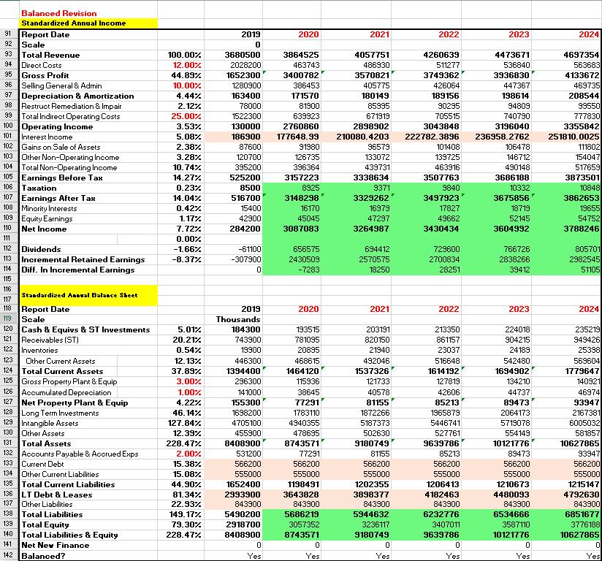

**WACC Analysis:**

In addition, a WACC analysis was conducted to find an appropriate after-tax discount rate of 5.24% to value these cash flows appropriately. The industry equity beta, and the capital asset pricing model were used to determine an overall cost of equity, and in a similar manner, the cost of debt. The spreadsheets shown below display the assumptions made needed to perform a WACC analysis and to set short and medium term growth rates.

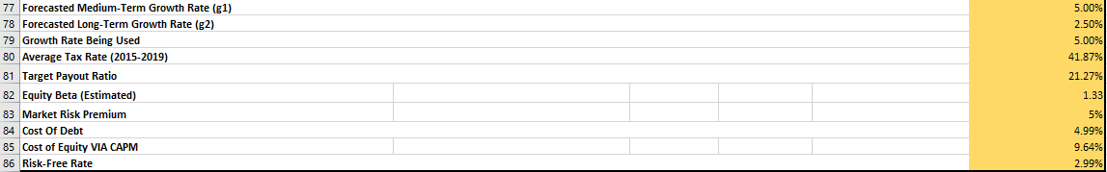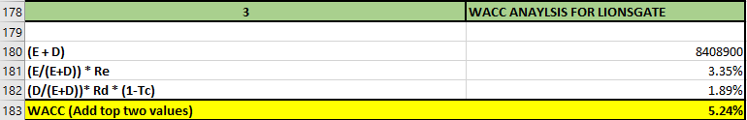

**Comparable Multiples Model:**

An attempt to value the firm via comparable multiples was executed, however, the results were inconsistent with the DCF model via the pro-forma analysis, as well as online sources. The issue seemed to stem from the sample of comparable firms used from Damadoran’s list of companies as the betas calculated via the regression analysis were very skewed. Moreover, due to the recent coronavirus crisis, the market is very volatile, and using comparables to analyze firms may be innacurate. Because of this, the results were omitted from the report.

**Synergies Valuation Via Free-Cash-Flow**

As stated prior, the primary driver of synergies that would arise between Netflix and Lionsgate arise from cost reductions. Netflix, for example, can spend a fraction of what Lionsgate does on promotion of their pictures. These synergies valued in this model are projected to become profitable within five years, but this is taking a conservative approach; they’re likely to serve as perpetual revenue streams for the future.

The after-tax free-cash-flow calculations were made using the pro-forma financial statements displayed above. The assumptions for selling off important PP&E, using accounts receivables as income, and most importantly, the distribution of Lionsgate’s intangible assets have all been factored into the pro-forma analysis. The cash flows are grown from past trends of revenue growth, and after 2024, they are expected to stop growing, keeping conservative approach. The terminal value of $8.1 billion displayed above valued in 2024 what Lionsgate’s operations are expected to provide indefinitely, assuming no further growth would take place. The total value added to Netflix present-valued to 2019 is worth $7.6 billion. The spreadsheets shown below display the free-cash-flow calculations needed to to value the overall synergies described earlier. 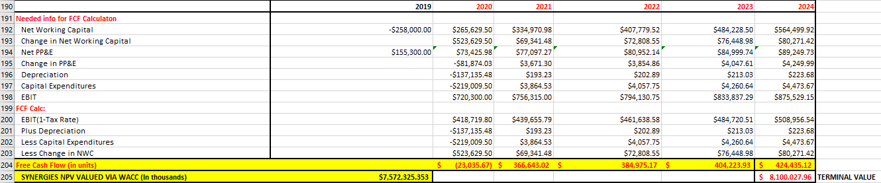

**Bid Range**

A bid range for the acquisition can be calculated using the comparable multiples method or by using the enterprise value of the target firm. The method chosen was using the enterprise value of the target firm since it was a more accurate representation of Lionsgate’s value. The maximum bid offered for the acquisition is Lionsgate’s enterprise value (net present value of firm) plus the value of the synergy. The enterprise value of Lionsgate is $4,470,640,000 and the value of the synergy is $7,572,325,000 as calculated above. Thereby, the maximum bid Netflix would offer in order to acquire Lionsgate is $12,042,956,000. The premium paid to Lionsgate shareholders for this acquisition ranges from 20%-25% above of their current share price. These figures were specifically chosen as they tend to match historical data. Considering a minimum premium of 20%, the minimum bid offered for the acquisition of Lionsgate will be $5,364,770,000. This value is equivalent to 20% more than the enterprise value of Lionsgate ($4,470,640,000 × (1.20)). That is, Netflix would be prepared to offer a minimum of $24, and a maximum of $26 per Lionsgate shares. With regards to alternative bidders, Netflix’s strategy is to maintain its minimum premium of 20% but offer a full cash only deal to incentivize Lionsgate into choosing Netflix over its competitors. Moreover in terms of Netflix’s bidding strategy, Netflix will offer Lionsgate its minimum bid of $5.3 billion as the first bid. Netflix will then increase bidding by a 20% margin of the total range between minimum and maximum bid (approx. $5.3 billion-$12 billion). This will provide Lionsgate with a total of 5 bids to consider, each increasing its predecessor by a 20% margin.

**Deal Feasibility**

As mentioned prior, the cash flows from acquiring Netflix are projected to grow for five years, and ultimately level out to zero growth indefinitely. The rationale behind zero-growth after five years is taken from the assumption that, after five years, the intangible assets acquired from Lionsgate will cease to provide *more* value that what they are projected to add after 2024. These cash flows will remain, but they will not grow.. Ultimately, this is what resulted in the total benefit of $7.5 billion. The financing required for Netflix to overtake Lionsgate would amount to $5.5 billion; if the acquisition were to succeed, Netflix shareholders would reap a hefty 36% return. The resulting value of Netflix after the acquisition takes place would be the combined value of both firms, coalesced with the synergies, or value added from the deal. This would amount to a combined enterprise value of $214.7 billion. For those with financial stake in Lionsgate, the return here lies in the premium paid to current shareholders. The 25% appreciation in firm value, in quantifiable terms, the $1.1 billion value-added will be the return Lionsgate will receive from this deal.

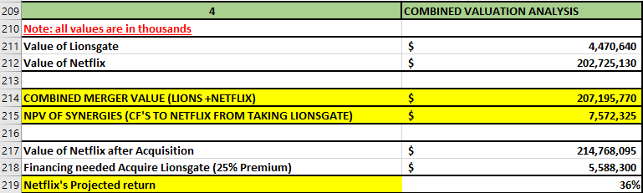

**Anti-Takeover Measures:**

The deal in play here could surely be viewed as a hostile takeover since Netflix will be attempting to purchase Lionsgate’s shares in entirety. There are several anti-takeover measures that Lionsgate can enact to prevent a potential buyer from gaining complete, or majority control. The first being amendments made to a corporation's charter that could perhaps prevent a takeover from happening; this anti-take over measure, however, lies in shareholders’ votes. The main provision in a charter amendment that could prevent Netflix from acquiring Lionsgate here is a supermajority provision. An arrangement of this sort would mean that more than a simple majority (51%) of votes, perhaps 60% or 70% instead, would be needed to approve the deal.

Perhaps the most powerful anti-takeover measure, often used as a last resort against an unwanted takeover, has to be the poison pill. It’s essentially a right given to shareholders to purchase additional shares at a discounted price in rare occurrences. Most corporations have a poison pill in place, and triggering it can make the acquisition of a company substantially expensive (historically by an additional 20%-30%). Effects of a poison pill, for example, can lead to shareholders’ voting rights being diluted, in addition to economic value being diluted.

In general, however, anti-takeover measures are used in corporations that are usually in good standing. Lionsgate, however, has been seeing a perpetual decline in company operations, and thus is riddled with uncertainty. That being said, these anti-takeover measures are not likely to be executed, especially since the production company has been the subject of a possible takeover amongst many buyers in the past year.

**Deal Structure**

The main focus of this deal is to create value. Simply purchasing Lionsgate’s assets would likely just add a new catalog of content of which Netflix could benefit from. This disadvantage here, however, is that Netflix would likely not take control of Lionsgate’s intangible assets such as patents, and licensing. Thus, it would be fruitless for the design of the deal to be structured around asset purchases. This is why a stock purchase acquisition is recommended for the benefits in that it is likely cheaper, less time-consuming, and potential tax minimizations can occur (CFI).

In a cash-for-stock deal, the target’s shareholders must pay taxes immediately on their capital gains, and recognize any losses. The buyer firm may step up the tax basis of the assets to reflect the acquisition premium provided it executes the appropriate election to do so. This increases the depreciation tax shield of the target post acquisition, and creates value for the buyer.

Because the investment required to completely purchase Lionsgate will require $5.5 billion, this will be a clear cash-for-stock transaction. Netflix’s current balance sheet states that they hold upwards of about $22 billion in excess cash, and thus for simplicity, it will be assumed that no additional debt will be taken on - other than that of acquiring Lionsgate’s long-term liabilities - and the purchase will be financed in-house.

**Executive Summary and Recommendations**

Throughout this report, the current state of the M&A market was analyzed, and the resources, capabilities, and opportunities, and threats of both Netflix and Lionsgate have been discussed. A valuation analysis was conducted on Lionsgate and Netflix to display where the companies stand in terms of financial health and future success. Cost reduction synergies were presented to show the potential benefits Netflix could receive in the event of acquiring Lionsgate. Furthermore, using the synergy value a bid range was calculated ($5.3 billion to $2 billion). Also, deal feasibility was measured and both shareholders profited in this win-win deal with Netflix’s shareholders reaping a 36% return, whereas Lionsgate’s shareholders benefit from the $1.1 billion premium at minimum. Finally, anti-takeover measures were considered and a cash for stock deal structure was put in place. Based on these results, acquiring Lionsgate seems to be a worthwhile investment, however, additional due diligence must take place. The 25% premium, for example, has room for negotiation as it believed that this could be *too high* of a premium to be paid. Conservative approaches were used to display that with the acquisition, substantial return is available, and should be taken advantage of. It is also recommended to not offer the max bid value for the acquisition, since this will equate to a NPV value of zero. Additional transaction expenses incurred in order to acquire Lionsgate will cause a loss. Furthermore, we also recommend a sensitivity analysis when calculating the synergy of the acquisition, in order to know the true drivers of the future cash flows. As the market moves into the second half of 2020, however, additional valuation analysis should take place, accounting for the possible effects that COVID-19 could have on both of these companies. Regardless, this team is recommending that Netflix should indeed offer a bid to acquire Lionsgate.

Works Cited

“Company.” Edited by Investis, – Lions Gate Entertainment Corp., investors.lionsgate.com/company.

“LGFB.” CNNMoney, Cable News Network, 4 June 2020, money.cnn.com/quote/chart/chart.html?symb=LGFB.

“Lions Gate Entertainment Corp. SWOT Analysis Matrix (Strengths, Weakness, Opportunities, Threats).” Fern Fort University, Fern Fort University, 2019, fernfortuniversity.com/term-papers/swot/nyse/2936-lions-gate-entertainment-corp-.php.

“LIONSGATE.” Lionsgate.com, 2020, www.lionsgate.com/about.

“Long-Term View.” Netflix, 2020, www.netflixinvestor.com/ir-overview/long-term-view/default.aspx.

“M&amp;A Synergies - How Cost Savings (Synergies) in M&amp;A Are Estimated.” Corporate Finance Institute, 7 Mar. 2019, corporatefinanceinstitute.com/resources/knowledge/valuation/mergers-acquisitions-ma-synergies/.

“Netflix, Inc.: Company Profile.” Vault, www.vault.com/company-profiles/media-entertainment/netflix.

“NFLX.” CNNMoney, Cable News Network, 4 June 2020, money.cnn.com/quote/financials/financials.html?symb=NFLX.

“Q1 2020 North American M&A Report.” PitchBook, Pitchbook, 29 Apr. 2020, pitchbook.com/news/reports/q1-2020-north-american-ma-report.

Analytics, Infront. “Lions Gate Entertainment Corp.” InfrontAnalytics, 2020, www.infrontanalytics.com/fe-EN/31117NC/Lions-Gate-Entertainment-Corp-/market-valuation.

Bhasin, Hitesh. “Marketing Strategy of Netflix - Netflix Marketing Strategy.” Marketing91, Marketing91, 29 May 2019, www.marketing91.com/marketing-strategy-of-netflix/.

Bloomenthal, Andrew. “How Company Stocks Move During an Acquisition.” Investopedia, Investopedia, 10 Apr. 2020, www.investopedia.com/ask/answers/203.asp.

Bylund, Anders. “3 Important Takeaways From Lionsgate Entertainments' Q3 Report.” The Motley Fool, The Motley Fool, 9 Nov. 2019, www.fool.com/investing/2019/11/09/3-important-takeaways-from-lionsgate-entertainment.aspx.

Donald, DePamphilis. “Developing a Merger and Acquisition Bidding Strategy.” Understanding Manda, 22 Nov. 2009, understandingmanda.wordpress.com/article/developing-a-merger-and-acquisition-2y7l67l8la2ns-4/.

Feiner, Lauren. “Disney Reports 58% Drop in Operating Income from Parks and Cruises, Its Worst-Hit Segment.” CNBC, CNBC, 5 May 2020, www.cnbc.com/2020/05/05/disney-dis-q2-2020-earnings.html.

Katz, Brandon. “Market Experts Weigh in on the Next Major Mergers & Acquisitions in Media.” Observer, Observer, 19 Nov. 2019, observer.com/2019/11/disney-fox-apple-netflix-media-merger-acquisition-predictions/.

Lewis, Marsha. “The Ultimate Guide to Synergies in M&amp;A: Types, Sources, Model.” DealRoom, DealRoom, 5 Feb. 2020, dealroom.net/blog/types-of-synergies-in-mergers-and-acquisitions-with-examples.

Rivera, Anthony. “Netflix SWOT Analysis (Internal &amp; External Strategic Factors).” Rancord Society, 10 Nov. 2019, www.rancord.org/netflix-swot-analysis-internal-external-strategic-factors.

Siddiqi, Maheen. “The Complete Guide to Netflix's Marketing Strategies.” Medium, Better Marketing, 26 June 2019, medium.com/better-marketing/netflix-marketing-strategies-8c6623fb1741.

Team, MBA Skool. “Lionsgate SWOT Analysis: Top Lionsgate Competitors, STP &amp; USP: Detailed SWOT Analysis of Brands.” MBA Skool-Study.Learn.Share., MBA Skool, 12 Apr. 2020, www.mbaskool.com/brandguide/media-and-entertainment/15508-lionsgate.html.